Activity 4
Ryan Coon
SWE-520
Professor Curtis Thompson
January 21, 2026

Part I.
Develop a sequence diagram showing the interactions involved when a student registers for a course in a university
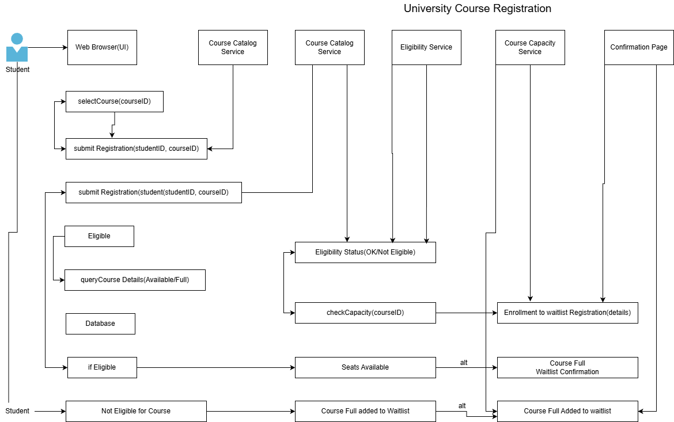
Part II.
Based on your experience with a bank ATM, draw an activity diagram that models the data processing involved when a customer withdraws cash from the machine.
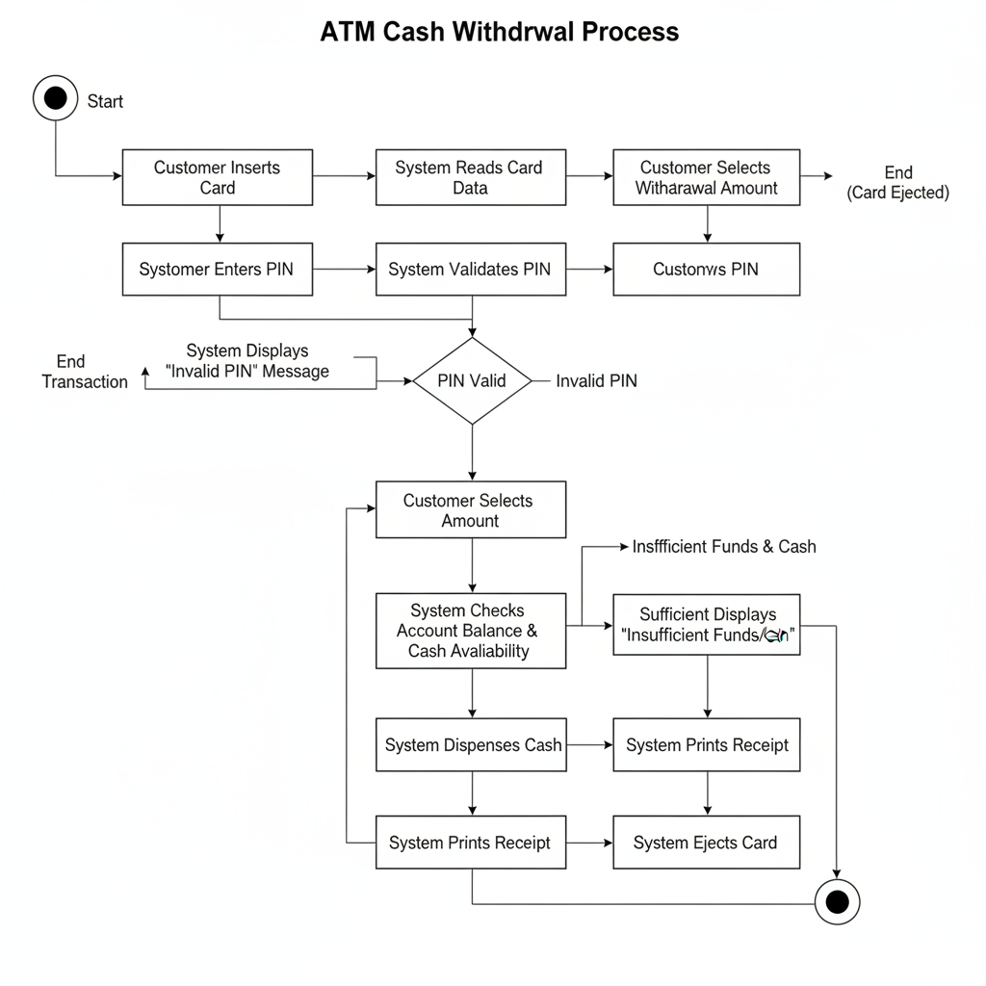
Part III.
10.1
Software dependability is crucial in most sociotechnical systems for several important reasons. First, dependable software ensures user trust and acceptance; if users perceive a system as unreliable, they may refuse to use it, undermining its effectiveness (CCSU, n.d.). Second, failures in sociotechnical systems can lead to significant economic losses or physical harm, making dependability essential to avoid costly consequences (UTC, n.d.). Third, dependable software supports safety-critical operations, such as in healthcare or transportation, where malfunctions can endanger lives. Fourth, it enhances system availability and continuity, which is vital for services that require constant uptime, like banking or communication networks. Fifth, dependable systems facilitate compliance with legal and regulatory requirements, which often mandate certain reliability and security standards. Finally, dependability reduces maintenance costs and downtime by minimizing unexpected failures and facilitating easier fault diagnosis and recovery (Sommerville, 2015). Together, these factors highlight why software dependability is a foundational attribute for the success and safety of sociotechnical systems.
10.2
The most important dimensions of system dependability typically include availability, reliability, safety, security, and resilience. Availability refers to the system’s readiness for correct service when needed, ensuring minimal downtime. Reliability is the probability that the system performs its intended function without failure over a specified period. Safety focuses on the system’s ability to operate without causing unacceptable risk or harm to people or the environment(Ninad, 2023). Security encompasses protection against unauthorized access, ensuring confidentiality, integrity, and availability of data and services. Resilience is the system’s capacity to recover from faults or attacks and continue operating effectively. These dimensions collectively define the trustworthiness and robustness of sociotechnical systems, which often integrate hardware, software, and human factors (UTC, n.d.). Understanding and balancing these dimensions is critical to designing systems that meet user expectations and regulatory requirements.
10.6
It is reasonable to assume that the use of dependable processes will lead to the creation of dependable software because dependable processes incorporate systematic practices designed to minimize errors, detect faults early, and ensure quality throughout the software development lifecycle. These processes typically include rigorous requirements analysis, formal verification, thorough testing, configuration management, and continuous validation, all of which contribute to reducing the likelihood of defects and increasing software reliability, safety, and security(Codacy, 2021). By following well-defined, repeatable, and measurable procedures, teams can better manage complexity, enforce standards, and maintain traceability, which collectively enhance the software’s dependability. Moreover, dependable processes often emphasize risk management and fault tolerance, enabling the identification and mitigation of potential issues before deployment. Empirical studies and industry experience have shown that disciplined engineering practices correlate strongly with improved software quality and dependability (Avizienis et al., 2004). Therefore, adopting dependable processes is a foundational strategy for producing software that meets stringent dependability requirements in sociotechnical systems.
References:
Avizienis, A., Laprie, J.-C. ., Randell, B., & Landwehr, C. (2004). Basic concepts and taxonomy of dependable and secure computing. IEEE Transactions on Dependable and Secure Computing, 1(1), 11–33. https://doi.org/10.1109/tdsc.2004.2
CCSU. (n.d.). CS 410/510 - Software Engineering class notes. Cs.ccsu.edu. https://cs.ccsu.edu/~stan/classes/CS410/Notes16/10-SystemDependability.html
Codacy. (2021, March 17). ISO/IEC 25010 Software Quality Model - Codacy | Blog. Blog.codacy.com. https://blog.codacy.com/iso-25010-software-quality-model
Ninad Lunge. (2023, November 18). Navigating the Seas of Dependability in Software-Intensive Systems. Medium. https://medium.com/@nlunge786/navigating-the-seas-of-dependability-in-software-intensive-systems-c309e88f207c
Sommerville, I. (2015). Software engineering (10th ed.). Pearson Education.
UTC. (n.d.). Chapter 11 -Security and Dependability. https://www.utc.edu/sites/default/files/2021-04/4900-11-security-dependability.pdf

